hjhjk
CICADA Study Update: Survey analysis

The CICADA Survey

Aims
The quantitative team is working on a three-wave online survey to explore how the COVID-19 pandemic influence people with chronic health conditions and/or from minoritised ethnic background. Through exploring the associations between their mental well-being, social support, health care, coping strategies, we aim to discover the potential future support direction.

Progress to date
We have conducted two waves of our longitudinal survey and have one further wave to go. We have just finished analysing the first wave analysis in which 4300 people took part. The second wave has now closed, and we have had 3500 valid responses. The third wave will take place in August.

Wave 1 Survey participants
Respondents had nearly equal numbers of white British and other ethnic individuals (57.9% was white British) as well as the proportion of people with and without chronic health conditions (43.9% had no chronic health condition). In addition, among the other ethnic group, people with black ethnicity had the highest ratio (17.2%) in the survey. Respondents were more likely to be immigrated (93% was immigrants). Undergraduate degrees were the most frequent degree in education (41.1%) and most of participants were employed. 50% with chronic health conditions. The age average was 36 years old.

Key findings from survey wave 1

Support from our communities can ease our mental discomfort during the COVID-19 pandemic

Our first wave survey results showed that people with chronic health conditions showed poorer mental well-being than those without. We also found that people from non-white British ethnic backgrounds also had worse mental well-being (see figure 1).

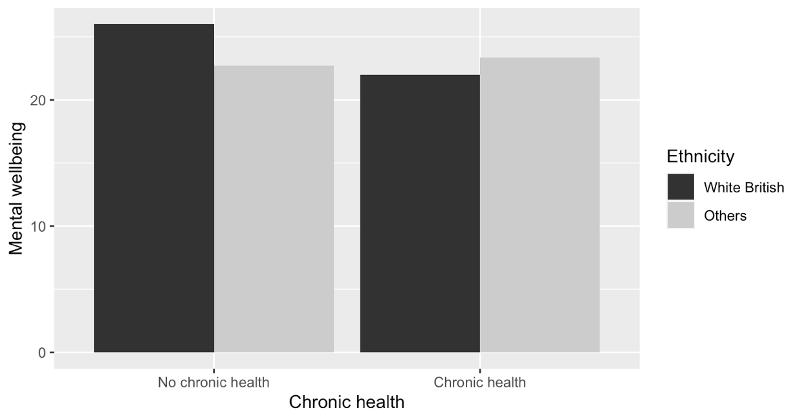
Figure 1: Overall, people with chronic health conditions and/or from non-white ethnic backgrounds showed poorer mental well-being.
However, if they sought help from people in their communities, the differences in mental well-being were attenuated. To be more specific, when people seek help from their wider communities, their mental well-being will not differ across groups (see figure 2). This suggested that social support can help relieve mental discomfort.

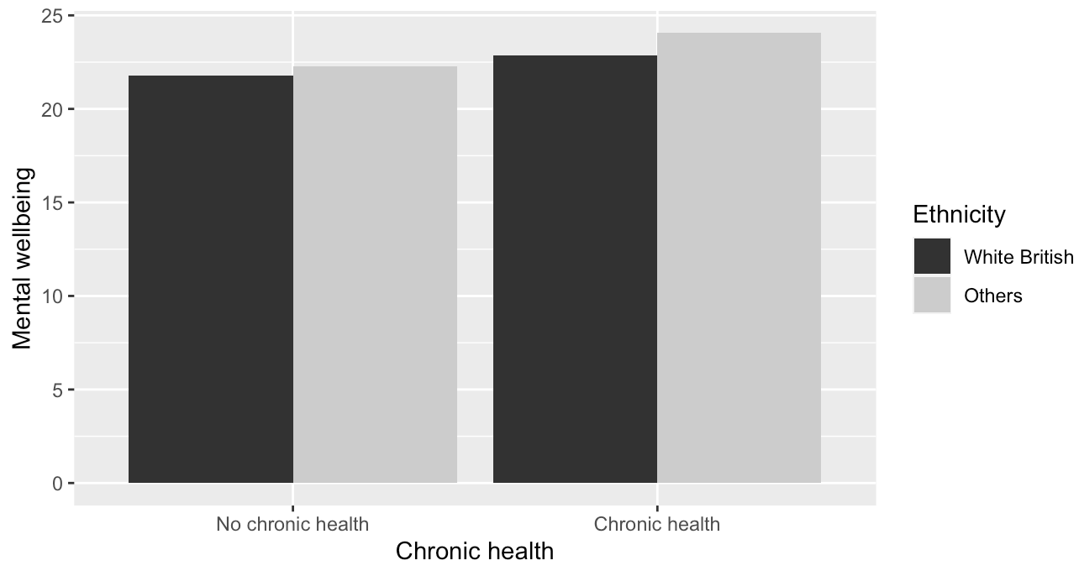
Figure 2: When people seek help from their community, their mental well-being is not associated with their health condition and ethnic background.

Summary
The initial analysis highlights the strong influence of social support on mental wellbeing.

